Earthquakes Practice: Time-travel graphs and Seismographs

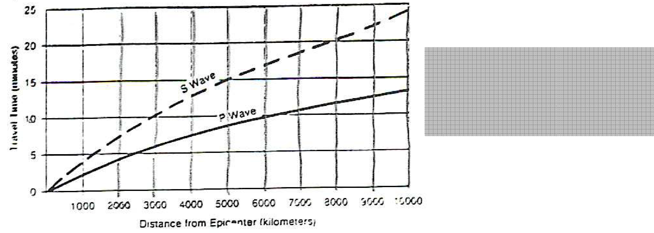

1. How long will it take a P wave to travel 8000km?
2. A P wave arrives at 3:00pm. If the S waves arrive at the seismograph station at 3:10pm, approximately how far was the earthquake from the station?

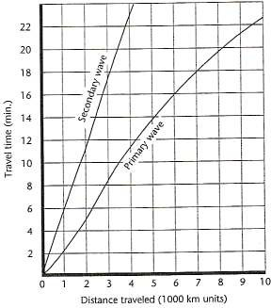



1. How long does it take for a primary wave to travel 2000 km?
2. How long does it take for a secondary wave to travel 2000 km?
3. How far does a secondary wave travel in 10 minutes?
4. How far does a primary wave travel in 10 minutes?
5. How much lag time between the two waves will there be at 4000 km?
6. Suppose both waves start together and travel for 5 minutes. Which wave will travel the farthest?

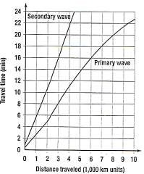



1. How long will it take a P wave to travel 9000 km?
2. An earthquake occurs at 4:00pm. If the P waves arrive at the seismograph station at 4:10pm and the S wave at 4:13pm, approximately how far was the earthquake from the station?
3. How far does a S wave travel in 22 minutes?
4. P waves first arrive at a station 5000 km away from the epicenter of the earthquake. How long did it take them to travel there?

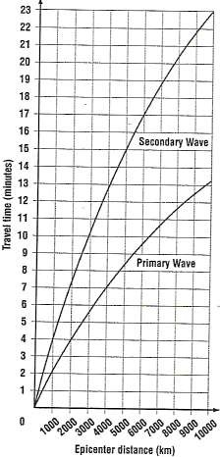

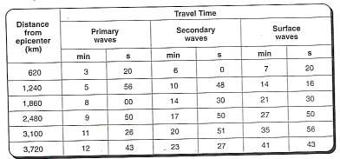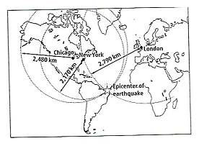

1. What is the difference in seismic wave arrival time if the epicenter is 5000 km away?
2. How far away is the epicenter if P waves take 12 minutes to get there?
3. It takes a P wave 6 minutes to reach a seismograph station that is

km away.

1. What happens to the time difference between primary and secondary waves as the distance traveled gets longer? Why?



1. On which continent did the earthquake occur?
2. How far was the earthquake from London?
3. How far was the earthquake from New York?
4. How far was the earthquake from Chicago?
5. How long did it take for the primary waves to reach Chicago?
6. Approximately, how long would it take for secondary waves to reach London?