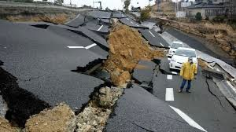
The Science of Earthquakes

Name: Class Period:

STUDENT LEARNING OBJECTIVE:
Students will review information about Earthquakes from 7th grade
Students will learn about seismology and how scientists measure earthquakes

INSTRUCTIONS:
- Read through the article (article is after the questions below) and highlight any information that will help you answer the Final Answer for our phenomenon, “How Can You Graph an Earthquake?”
- Answer the following questions using complete sentences.
- Upload your assignment to CANVAS

QUESTIONS:
- Explain the different between a hypocenter and an epicenter.

- What are the differences between foreshocks, mainshock, and aftershocks?

- Explain what tectonic plates are, along with their plate boundaries, and how they work.

- What does energy have to do with the earth shaking?

- How are earthquakes recorded? Explain what the machine does.

- How are the size of earthquakes measured? What is the unit of measurement and how does it work?

- How are P- and S-waves the same? How are P- and S-waves different? (Offer at least 2 comparisons and 2 points of contrast)

- What is triangulation and how does it help determine an epicenter. Explain the details involved.

- Can scientists know if there will be an earthquake on a given fault in the future? Explain.

Earthquake Hazards

The Science of Earthquakes
Originally written by Lisa Wald (U.S. Geological Survey) for “The Green Frog News”

Status - Active

What is an earthquake?
An earthquake is what happens when two blocks of the earth suddenly slip past one another. The surface where they slip is called the fault or fault plane. The location below the earth’s surface where the earthquake starts is called the hypocenter, and the location directly above it on the surface of the earth is called
the epicenter.
Sometimes an earthquake has foreshocks. These

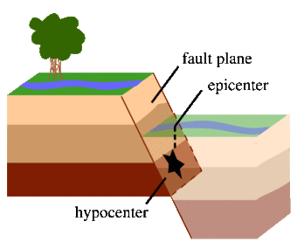
A normal (dip-slip) fault is an inclined fracture where the rock mass above an inclined fault moves down (Public domain.)

Explore More Science
Earthquake Hazards Earthquakes
Faults, Earthquake Geology, and Special Earthquake Studies Earthquake Processes and Eﬀects
Natural Hazards

are smaller earthquakes that happen in the same place as the larger earthquake that
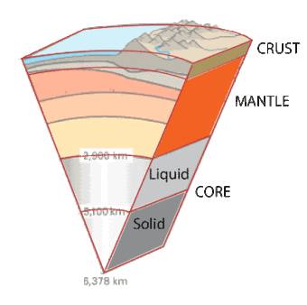
follows. Scientists can’t tell that an earthquake is a foreshock until the larger earthquake happens. The largest, main earthquake is called the mainshock. Mainshocks always have aftershocks that follow. These are smaller earthquakes that occur afterwards in the same place as the mainshock. Depending on the size of the mainshock, aftershocks can continue for weeks, months, and even years after the mainshock!

What causes earthquakes and where do they happen?
The earth has four major layers: the inner core, outer core,
mantle and crust. The crust and the top of the mantle make up a thin skin on the surface of our planet.
But this skin is not all in one piece – it is made up of many pieces like a

puzzle covering the surface of the earth. Not only that, but these puzzle pieces keep slowly moving around, sliding
A simpliﬁed cartoon of the crust (brown), mantle
(orange), and core (liquid in light gray, solid in dark gray) of the earth. (Public domain.)

past one another and bumping into each other. We call these puzzle pieces tectonic plates, and the edges of the plates are called the plate boundaries. The plate boundaries are made up of many faults, and most of the earthquakes around the world occur on these faults. Since the edges of the plates are rough, they get stuck while the rest of the plate keeps moving. Finally, when the plate has moved far enough, the edges unstick on one of the faults and there is an earthquake.

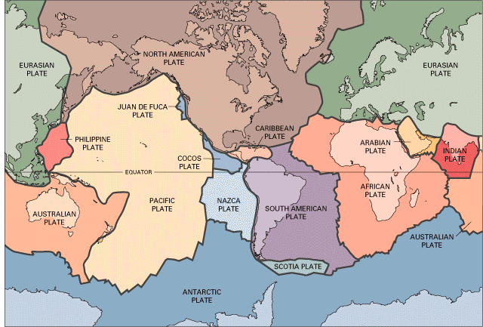
The tectonic plates divide the Earth's crust into distinct "plates" that are always slowly moving. Earthquakes are concentrated along these plate boundaries. (Public domain.)

Why does the earth shake when there is an earthquake?
While the edges of faults are stuck together, and the rest of the block is moving, the energy that would normally cause the blocks to slide past one another is being stored up. When the force of the moving blocks ﬁnally overcomes the friction of the jagged edges of the fault and it unsticks, all that stored up energy is released. The energy radiates outward from the fault in all directions in the form of seismic
waves like ripples on a pond. The seismic waves shake the earth as they move through it, and when the waves reach the earth’s surface, they shake the ground and anything on it, like our houses and us!

How are earthquakes recorded?
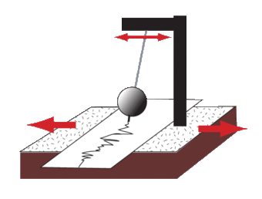
Earthquakes are recorded by instruments
called seismographs. The recording they make is called a seismogram. The seismograph has a base that sets ﬁrmly in the ground, and a heavy weight that hangs free.
When an earthquake causes the ground to shake, the base of the seismograph shakes too, but the hanging weight

does not. Instead the spring or string that it is hanging from absorbs all the movement. The diﬀerence in position between the shaking part
The cartoon sketch of the seismograph shows how
the insrument shakes with the earth below it, but the recording device remains stationary (instead of the other way around). (Public domain.)

of the seismograph and the motionless part is what is recorded.

How do scientists measure the size of earthquakes?
The size of an earthquake depends on the size of the fault and the amount of slip on the fault, but that’s not something scientists can simply measure with a measuring tape since faults are many kilometers deep beneath the earth’s surface. So how do they measure an earthquake? They use the seismogram recordings made on
the seismographs at the surface of the earth to determine how large the earthquake was (ﬁgure 5). A short wiggly line that doesn’t wiggle very much means a small earthquake, and a long wiggly line that wiggles a lot means a large earthquake. The length of the wiggle depends on the size of the fault, and the size of the wiggle depends on the amount of slip.

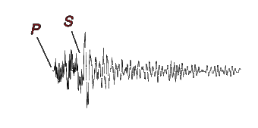
The size of the earthquake is called its magnitude. There is one magnitude for each earthquake. Scientists also talk about theintensity of shaking from an earthquake, and this varies depending on where you are during the earthquake.

How can scientists tell where the earthquake happened?
Seismograms come in

An example of a seismic wave with the P wave and S wave labeled. (Public domain.)
handy for locating earthquakes too, and being able to see the P wave and the S wave is

important. You learned how P & S waves each shake the ground in diﬀerent ways as they travel through it. P waves are also faster than S waves, and this fact is what allows us to tell where an earthquake was. To understand how this works, let’s compare P and S waves to lightning and thunder. Light travels faster than sound, so during a thunderstorm you will ﬁrst see the lightning and then you will hear the thunder. If you are close to the lightning, the thunder will boom right after the lightning, but if you are far away from the lightning, you can count several seconds before you hear the thunder. The further you are from the storm, the longer it will take between the lightning and the thunder.
P waves are like the lightning, and S waves are like the thunder. The P waves travel faster and shake the ground where you are ﬁrst. Then the S waves follow and shake the ground also. If you are close to the earthquake, the P and S wave will come one right after the other, but if you are far away, there will be more time between the two.
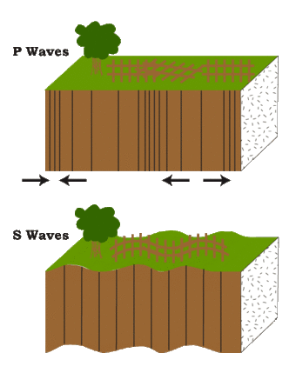
By looking at the amount of time between the P and S wave on a seismogram recorded on a seismograph, scientists can tell how far away the earthquake was from that location. However, they can’t tell in what direction from the seismograph the earthquake was, only how far away it was. If they draw a circle on a map around the station where the radius of the circle is the determined distance to the earthquake, they know the earthquake lies somewhere on the circle. But where?
Scientists then use a method

called triangulation to determine exactly where the earthquake was (see image below). It is called triangulation because a triangle has three sides, and it takes three seismographs to locate an
P Waves alternately compress and stretch the crustal material parallel to the direction they are propagating. S Waves cause the crustal material to move back and forth perpendicular to the direction they are travelling. (Public domain.)

earthquake. If you draw a circle on a map around three diﬀerent seismographs where the radius of each is the distance from that station to the earthquake, the intersection of those three circles is the epicenter!

Can scientists predict earthquakes?
No, and it is unlikely they will ever be able to predict them. Scientists have tried many diﬀerent ways of predicting earthquakes, but none have been successful. On any particular fault, scientists know there will be another earthquake sometime in the future, but they have no way of telling when it will happen.

Is there such a thing as earthquake weather? Can some animals or people tell when an earthquake is about to hit?
These are two questions that do not yet have deﬁnite answers. If weather does aﬀect earthquake occurrence, or if some animals or people can tell when an earthquake is coming, we do not yet understand how it works.

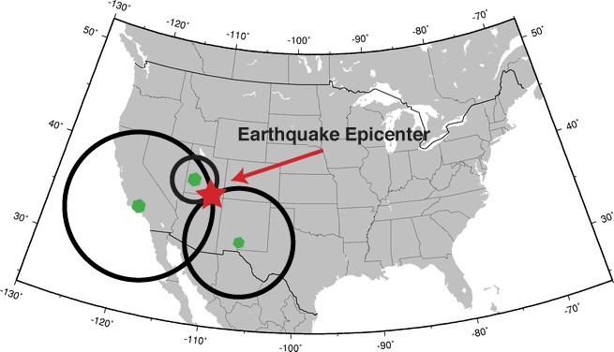

Triangulation can be used to locate an earthquake. The seismometers are shown as green dots. The calculated distance from each seismometer to the earthquake is shown as a circle. The location where all the circles intersect is the location of the earthquake epicenter. (Public domain.)

C hildren's Privacy Policy

