Light Waves Test
Instructions: Read the following scenario and answer the questions. You may diagram or use pictures if you’d like to do so. Make sure that you use every vocabulary word in the vocabulary box in your answers. Make sure that you include a definition or a diagram for the words you use to show that you understand what they mean.

Vocabulary Words:

Reflection Refraction Waves Amplitude Frequency Energy Wavelength

Angle of Incidence Angle of Reflection

Imagine you are sitting at a table with a red apple in front of you. Your friend closes the door and turns off all the lights. It is totally dark in the room. There are no windows in the room or cracks around the door. No light can enter the room.
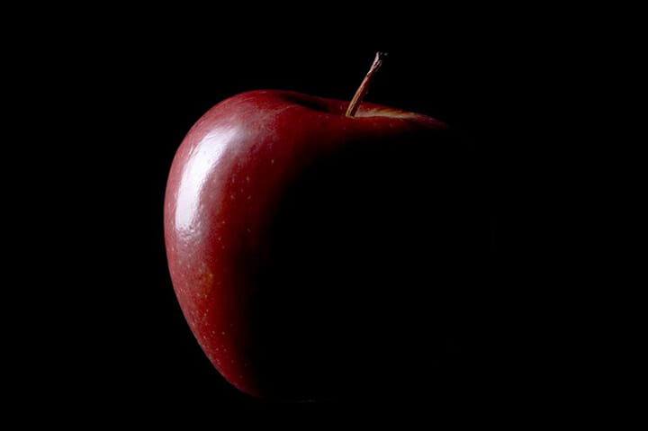
1-Which statement best describes how you would see the apple in the dark?
a. You will not see the red apple, regardless of how long you are in the room.
b. You will see the red apple after your eyes have had time to adjust to the darkness.
c. You will see the apple after your eyes have had time to adjust to the darkness, but you will not see the red color.
d. You will see only the shadow of the apple after your eyes have had time to adjust to the darkness.
e. You will see only a faint outline of the apple after your eyes have had time to adjust to the darkness.
2-Explain your answer. Why did you choose the answer that you did?

3-Why was the apple red in the light?

4-If you look closely at a bubble in the light, you can see rainbows on the surface. Why does this happen?
