The Bicycle as a System
Name:
Class Period:
- Look up the scientific definition for the term SYSTEM: Write the definition both here and in your science journal.
- Look at the various parts of a mountain bike. Can the bike can be seen as a complete system? Explain, why or why not.
- Look up the scientific definition for the term SUBSYSTEM. Write the definition both here and in your science journal.

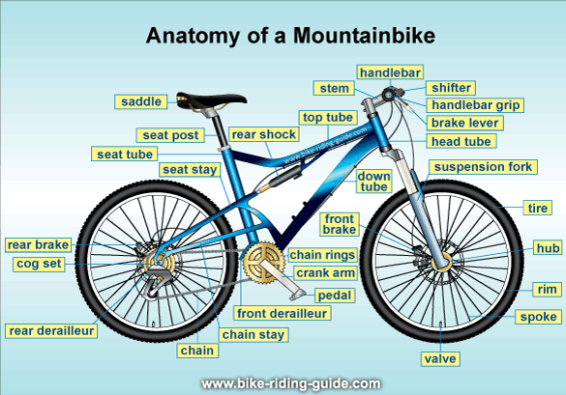

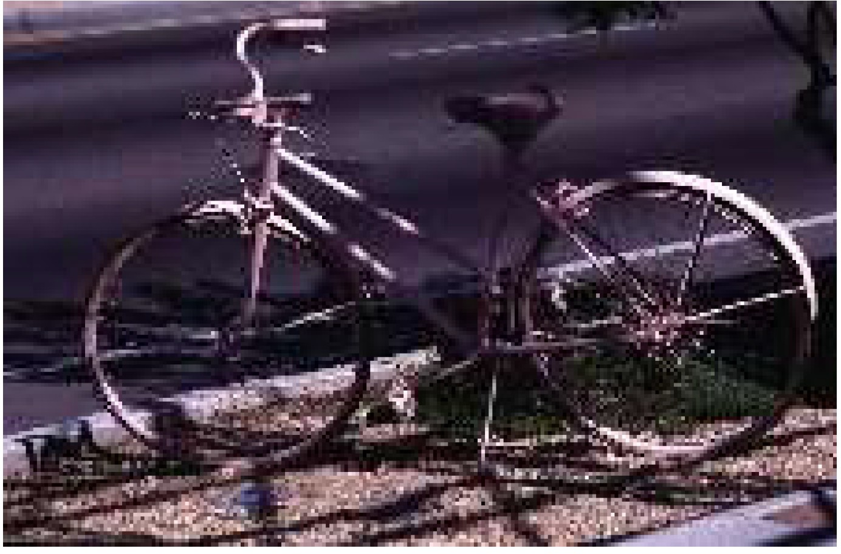
Review the information from the The Science of Cycling http://www.exploratorium.edu/cyclinq/ (http://www.exploratorium.edu/cyclinq/) , on The Exploratorium website . Apply your knowledge of systems to answer the questions below and then be prepared to present your answers to the class.

4. Complete the table below to identify the following:
    - Name the parts of the bicycle's subsystem.
    - Tell what function each part has and how it contributes to the subsystem
    - For the bicycle subsystem to work, what input must it receive? What, if any output does the subsystem produce?

 | Parts | Function | Input | Output
The Wheel
Drivers and Gears
Frames & Materials

Brakes & Steering
Aerodynamics

Could any part of this bicycle be made of a different material and still help the bicycle carry out its function?

Can any one part of the bicycle carry out the job of the whole bicycle? Explain your answer.

Can you take a part from another bicycle and use it to replace a part in this bicycle and still have the bicycle carry out its function?

Could some parts of the bicycle be arranged differently so that the system will still carry out its function? Explain your answer.

Does the bicycle require symmetry among any of its parts? If so, describe the symmetry.

What will happen to the bicycle if one part, such as a spoke, breaks? What if all the spokes on a wheel break?

Is it useful to think of a bicycle as a system? Justify your answer.

© CopyriQht AAAS 2017. All riQhts reserved. Terms of Us (http://www.aaas.or /terms of use.shtml

AAAS

